# Practical - 1

## Aim: TCP Scanning using nmap

nmap -V : Used to know version of nmap

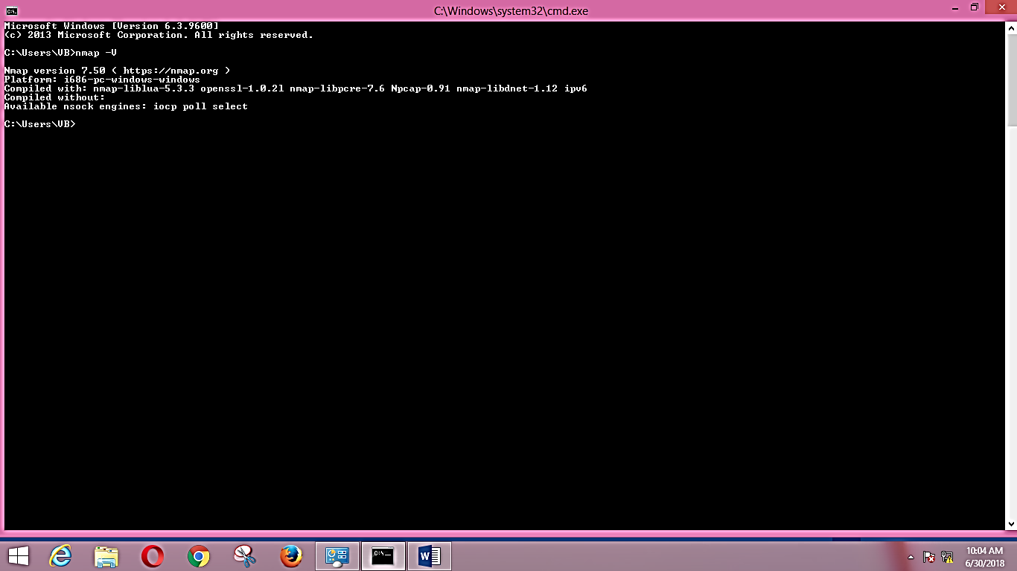

nmap IP_addr : To scan the IP

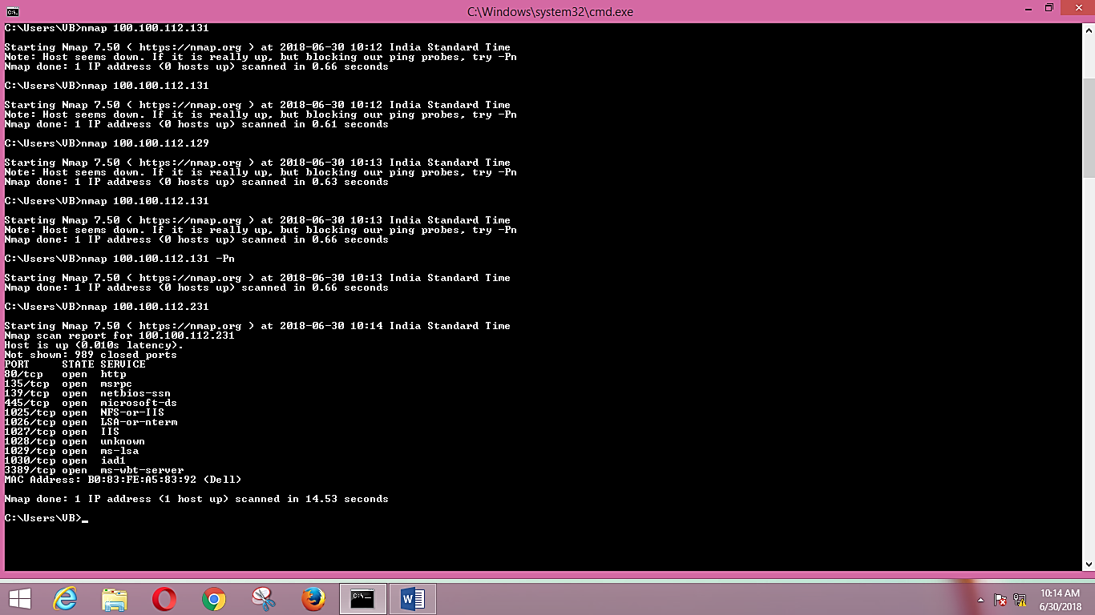

To scan range of IP address

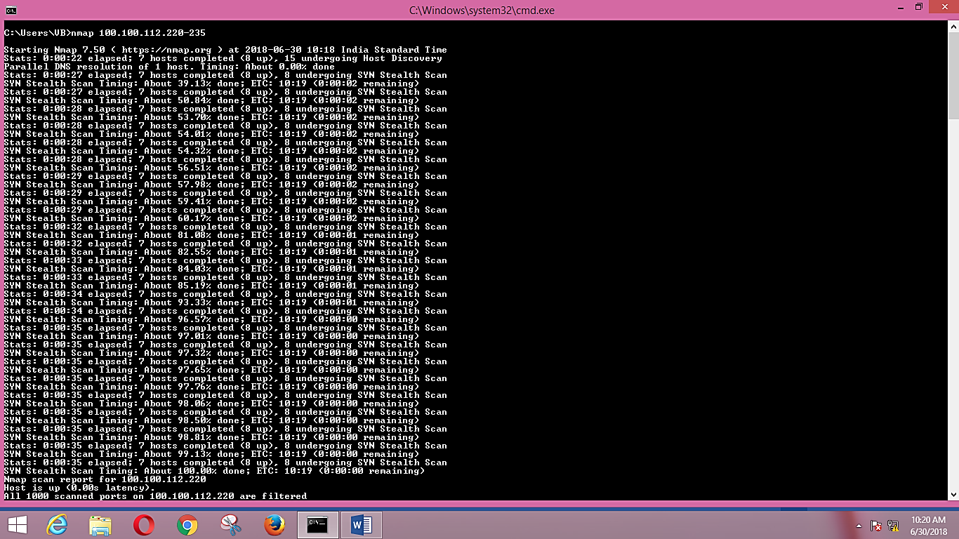

To scan the subnet of IP

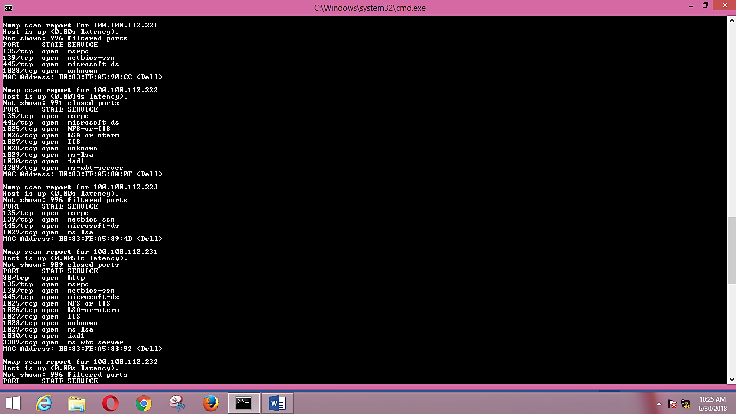

To scan OS of IP

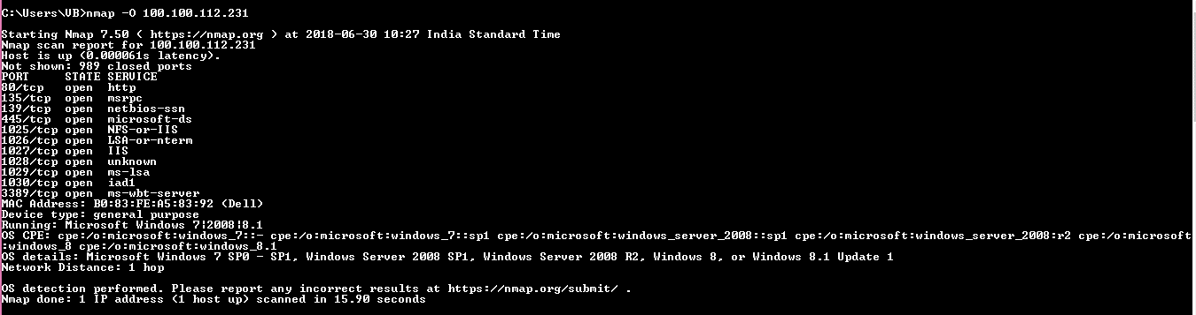

# Practical - 2

## Aim: Port Scanning using nmap

To scan port IP

Nmap –p port_num ip

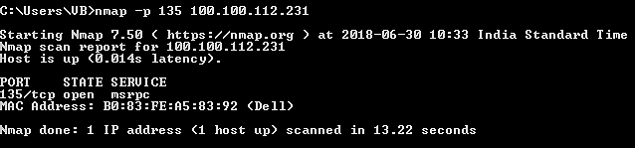

To scan range of port IP

Nmap –p port_range ip

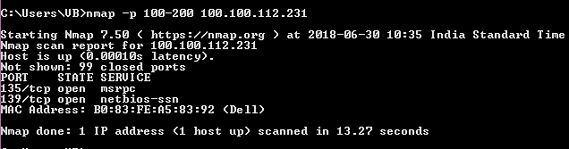

To scan all the ports of IP

Nmap –p- ip

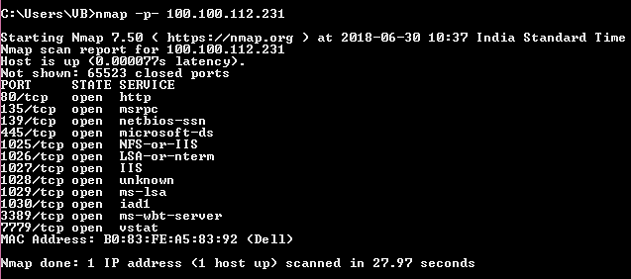

To scan most common ports of IP

Nmap -f ip

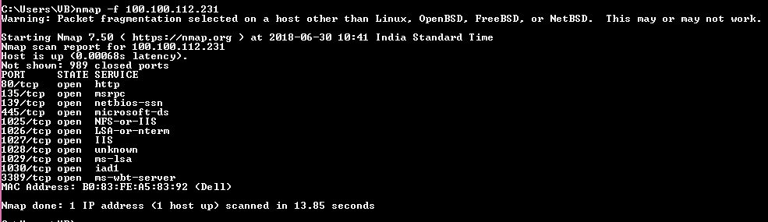

To scan ports in form of IPv6 IP

nmap -6

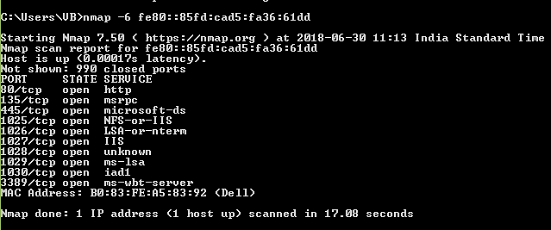

Show ports with version

nmap –sV

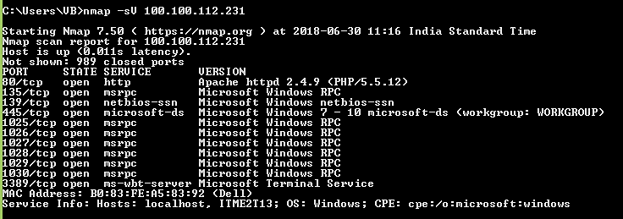

Show ports without version

nmap –PS

